**Experiment 4**

**Aim:** Linux Process management commands

**Software:** Ubuntu

**Procedure:** Use various process management commands in terminal.

**Output:**

* **Show Process, top, bg**

Type process name to view that process

To view a dynamic, real-time view of running processes, use the "top" command.

To put a process in the background, use the "bg" command.

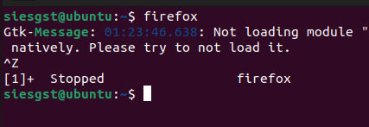



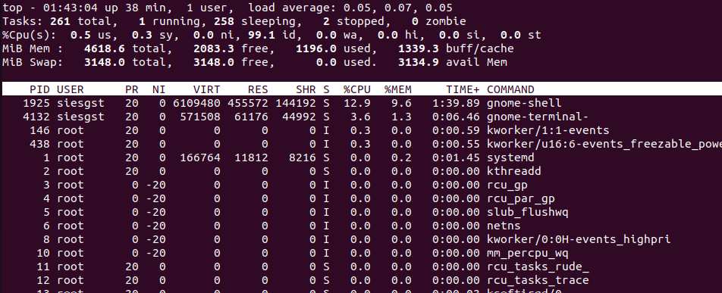

* **pid of, ps,**

kill PID of command displays process ID, ps command displays process information, and kill command terminates a running process in Linux.

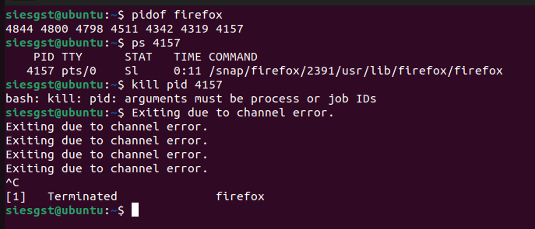

* **df –h**

The "df -h" command displays disk usage information, which is important for monitoring and optimizing system performance in Linux. It can be used to identify processes using significant disk space and to optimize storage capacity.

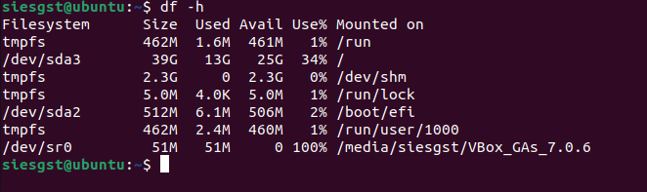

* **free –m, free – g**

"free -m" and "free -g" are Linux commands that display memory usage information for process management, including the total amount of memory, memory used by applications, and available memory.

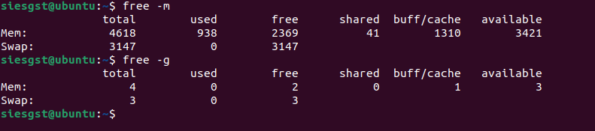

* **ps afx**

The "ps afx" command in Linux is used to display the process hierarchy in a tree format, making it easy to visualize the relationships between processes and their parent/child processes.

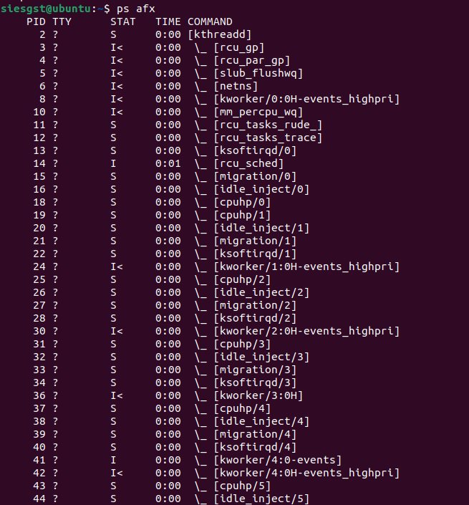

* **pstree**

The "pstree" command can be used to display the process hierarchy in a tree format, making it easy to visualize the relationships between processes and their parent/child processes.

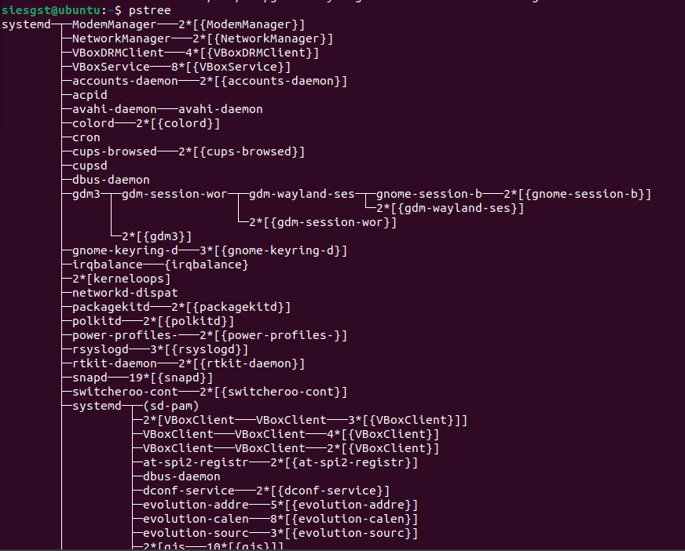

* **renice**

The "renice" command in Linux is used to change the priority of a running process, allowing system administrators to adjust the amount of CPU time allocated to the process and manage system resources more effectively.

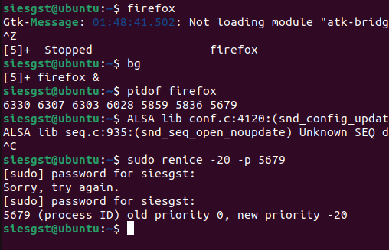

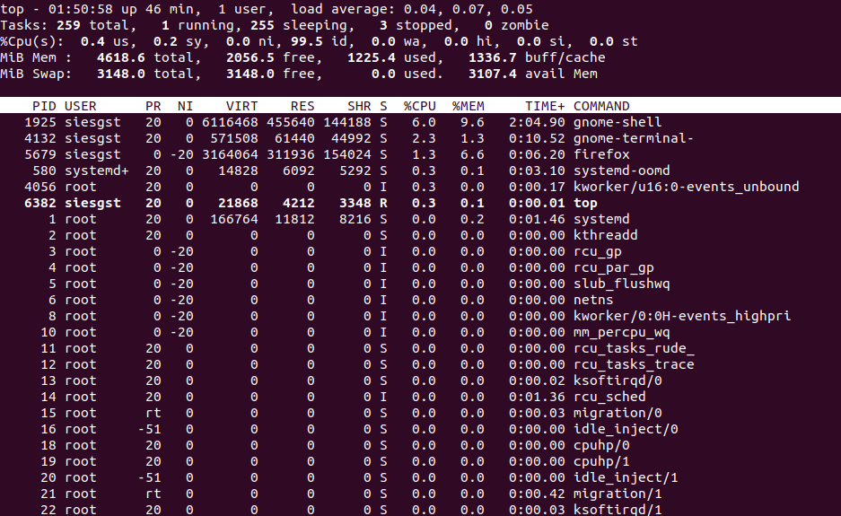

* **echo $USER. $HOME, $OSTYPE, $PATH, $SHELL**

"echo $USER" displays the current user's username, "echo $HOME" displays the current user's home directory, "echo $OSTYPE" displays the operating system type, "echo $PATH" displays the directories where executable files are searched for, and "echo $SHELL" displays the current user's default shell.

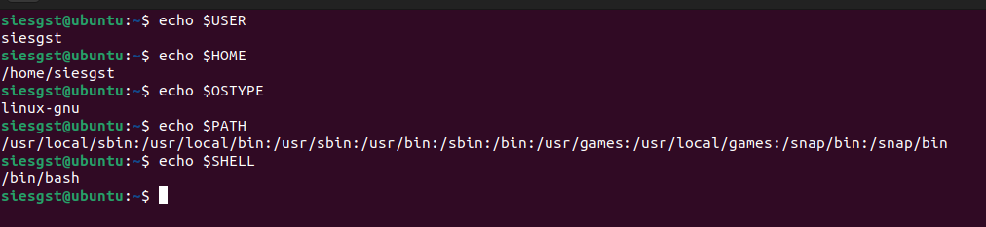

**Conclusion:**

Successfully executed processes management commands. Linux process management involves using various commands and tools to monitor system resources, manage process priorities, and terminate processes. This is important for optimizing system performance and troubleshooting issues. By mastering Linux process management, system administrators can ensure that critical processes have the resources they need to run smoothly and keep their systems running efficiently.